First

Computer右鍵->Properties->Advanced system settings->Advanced->Environment Variables->User variables for crayflames ->

[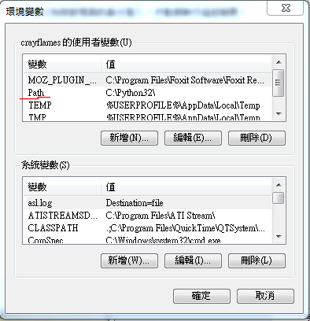](https://sites.google.com/a/crayflames.co.cc/crayflames/python/ptp/pythondehuanjingbianshu/path.PNG?attredirects=0)

Second

into command pip dir

fellow this ↓

